INTRODUCTION TO MEDICINAL PLANTS
Medicinal plants, also called as medicinal herbs, have been discovered and used in traditional medicine practices since prehistoric times. Plants synthesize hundreds of chemical compounds for various functions, including defense and protection against insects, fungi, diseases, against parasites and herbivorous mammals.
Medicinal plants are widely used as folk medicine in non industrialized societies, mainly because they are readily available and cheaper than modern medicines. In many countries, there is little regulation of traditional medicine, but the world health organization coordinates a network to encourage safe and rational use. The botanical herbal market has been criticized for being poorly regulated and containing placebo and pseudoscience products with no scientific research to support their medical claims. Medicinal plants face both general threats, such as climate change and habitat destruction, and specific threat of over collection to meet market demand.
OBJECTIVES OF MEDICINAL PLANTS
- Medicinal plants are their extracts are natural resources of compounds used for ethno medical and phyto therapy. They are also a source of natural product used in the new related compound and drugs for conventional medicine.
- To prevent and treat diseases using natural plant resources.
- The food and agriculture organization estimated in 2002 that over 50,000 medicinal plants are used across the world. The royal botanic gardens knew more conservatively estimated in 2016 that 17,810 plant species have a medicinal use, out of some 30,000 plants for which a use of any kind is documented.
- This brings attendant risks of toxicity and other effects on human health, despite the safe imagine of herbal medicines.
- The increasing treatments interest herbal medicines requires a comprehensive assessment of research data in this field focus future efforts.
- A medicinal plants is a plant that is used with the intention of maintaining health, to be administered for a specific condition, or both, whether in modern medicine or in traditional medicine.
- The world health organization estimate without reliable data, that some 80 percent of world's population depends mainly on traditional medicine (including but not limited to plants); perhaps some to billion people are largely reliant on medicinal plants.

ADVANTAGES OF MEDICINAL PLANTS
- Natural and safe: Derived from plants and generally well tolerated by the body.
- Fewer side effects: Cause minimal adverse effects compared to synthetic drugs.
- Cost effective: Easily available and affordable for most people.
- Wide therapeutic uses: Used to treat and prevent various diseases.
- Rich source of bioactive compounds: contain active constituents responsible for medicinal action.
- Used in traditional and modern medicine: From the basis of Ayurveda and many modern drugs.
REVIEW OF CONSTIPATION
Constipation is a common digestive issue characterized by infrequent bowel movements or difficulty passing stool. It can leads to discomfort and can impact quality of life. It happens most often due to changes in diet or routine, or due to inadequate intake of fiber. You should call a healthcare provider if you have severe pain, blood in your stool or constipation that lasts longer than three weeks.
Complications from constipation may includes hemorrhoids, and fissure or fecal impaction. The normal frequency of bowel movements in adults is between three per day and three per week. Babies often have three to four bowel movements per day while young children typically have two to three per day.
Constipation common cause include slow movement of stool within the colon, irritable bowel syndrome, and pelvic floor disorder. Underlying associated diseases include hypothyroidism, diabetes, Parkinson disease, vitamin B12 deficiency, colon cancer and inflammatory bowel disease. Constipation is more concerning when there is weight loss or anemia, blood is present in the stool.


Symptoms:
- Infrequent bowel movements (typically fewer than three times a week)
- Hard or lumpy stools
- Straining during bowel movements
- A feeling of incomplete evacuation
- Abdominal discomfort or bloating
- Nausea

Diagnosis:

Diagnosis typically involves:
- Medical History: Discussion of symptoms, diet, and lifestyle.
- Physical Examination: Checking for abdominal tenderness or masses.
- Stool Analysis: Testing for blood or other abnormalities.
- Imaging Test: X-rays or other imaging may be done if a blockage is suspected.
- Colonoscopy: In some cases, to rule out other conditions.

Treatment:
Treatment options depends on the severity and underlying causes, and may include:
1. Dietary change:
- Increase fiber intake ( fruits, vegetables, whole grains ).
- Ensure adequate hydration.
2. Lifestyle modifications:
- Regular exercise.
- Establishing a regular bath routine.
3. Over the counter medication:
- Laxatives ( bulk forming, osmotic, stimulant).
- Stool softeners.
4. Prescription medications:
- If over the counter options are in affective, doctor may prescribe medications specifically for chronic constipation.
5. Biofeedback therapy:
- Useful for those with pelvic floor dysfunction.
6. Surgery:
- Rarely required but may be considered in severe cases related to anatomical issues.
 Prevention:
Prevention measures include:
- Eating a balanced diet rich in fiber.
- Staying hydrated by drinking plenty of fluids.
- Regular physical activity.
- Establishing a routine for bowel movements, responding promptly to the urge.

Prognosis:
- Acute constipation: often resloves with dietary changes, increased fluid intake, and lifestyle modification. Over the counter laxatives can also be effective.
- Chronic constipation: This may require a more comprehensive approach, including a review of medication, dietary adjustment, regular exercise, and sometimes prescription medications. With appropriate management many people can find relief.


SLIPPERY ELM
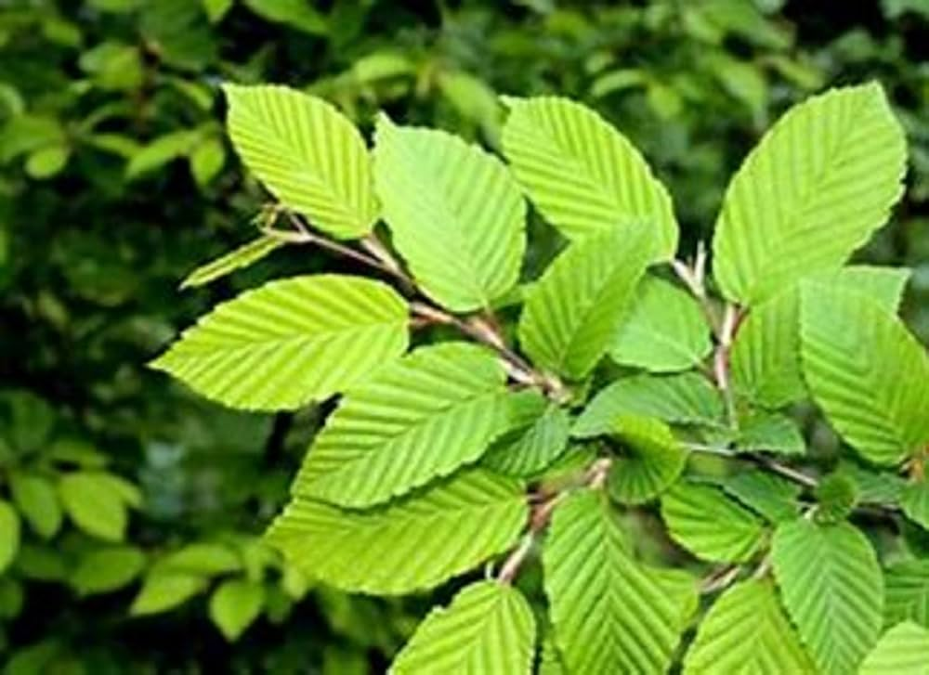
Synonyms: Indian elm, red elm, soft elm
Biological source: Biological source of slippery elm is the dried inner bark of the tree species ulmus rubra.
Family: Ulmaceae
Geographical source: Slippery elm is native to Eastern North America with its geographical range extending from south eastern North Dakota. It is also found in US and Canada.
Chemical constituents:
Constituent type | Example compunds | Functions
Mucilage | Polysaccharides(pentose, hexoses) | Demulcent &soothing
Tannins | Polyphenols | Astringent & Anti inflammatory
Starch | Amylase, amylopectin | Nutritive, protective
Minerals | Ca, Mg, Na, Fe | Nutrient support
Phytosterols | Beta - sitosterol | Anti inflammatory

Mechanism of action (MOA):
- When slippery elm is ingested it coats the intestinal walls and absorbs water and increases the stool bulk and softness
- Mucilage forms a slippery layer on stomach and intestinal wall
- It increases the stool volume and stimulates the peristaltic movement
- Promote smooth passage of stool



Medicinal uses:
- Digestive health: Gastric, ulcers, diarrhoea, constipation, often used to soothes mucosa, coats stomach.
- Respiratory: sore throat, cough, bronchitis, acts as demulcent and expectorant.
- Skin: Help to reduce burns, wounds, acts as healing and anti inflammatory.
Marketed product:
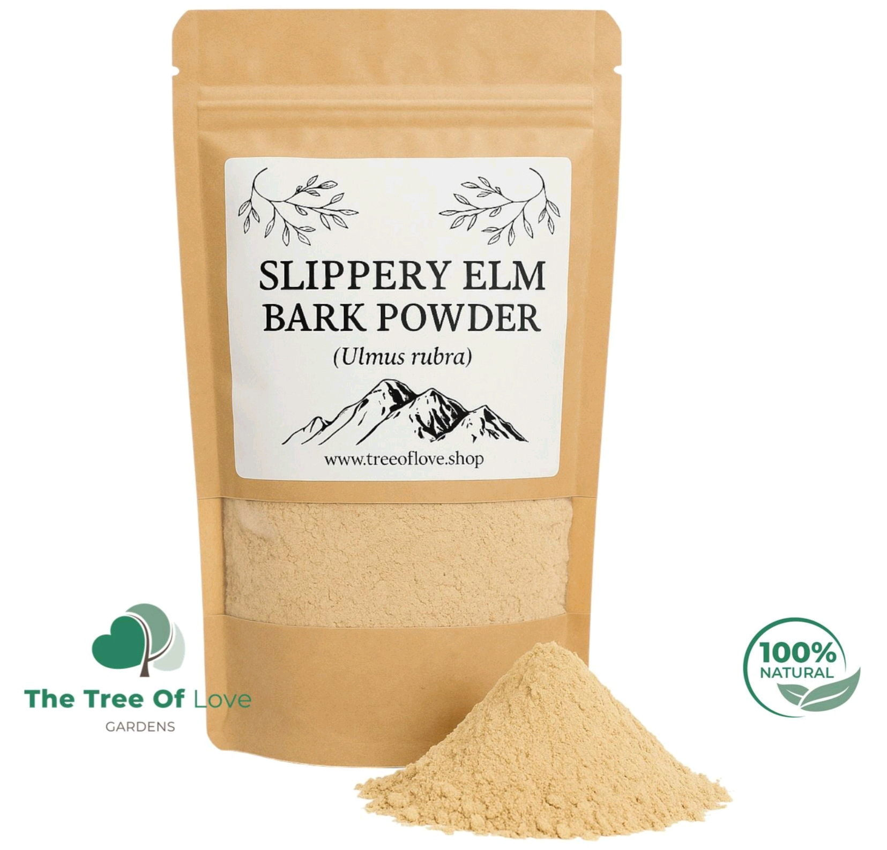

DANDELION ROOT
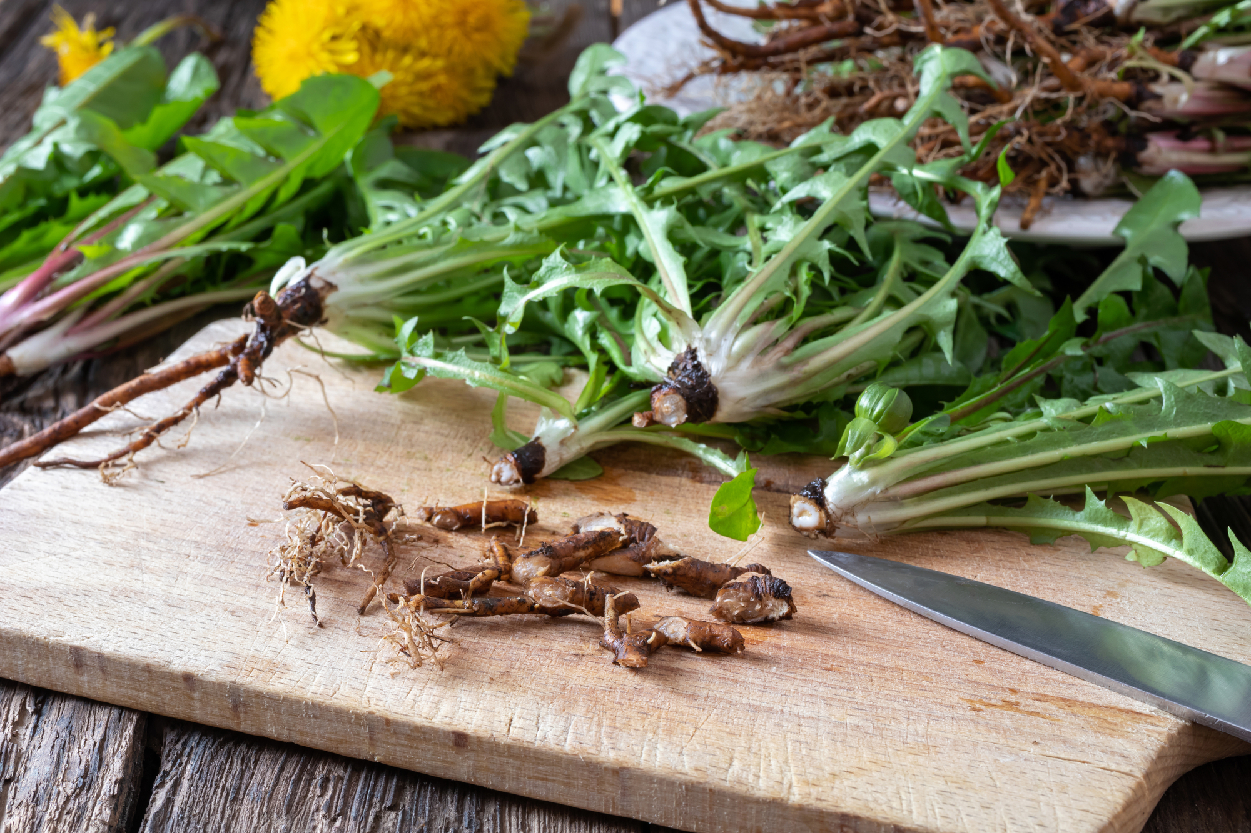
Synonym: common dandelion, loin's tooth, Blowball, Faceclock
Biological source: The biological source of dandelion root is the dried root of the plant Taraxacum officinale.
Family: Asteraceae (also known as the compositae family)
Geographical source: Native to Europe and Asia, dandelion are now found worldwide, especially in temperate regions. They thrive in disturbed soils, gardens, and lawns.
Chemical constituents: Dandelion root contains several bioactive compounds, including:
Constituent type | Example compounds
Inulin | A type of soluble fiber that supports digestive health.
Vitamins | Particularly high in vitamins A, C, & K.
Minerals | Includes potassium, calcium, magnesium & iron.

Mechanism of action (MOA):
- It contains bitter principles (Taraxacin) which stimulates digestive secretions
- Increases the secretion (choleretic action)
- Improves fat digestion and reduce sluggish bowel activity
- Stimulates the intestinal motility
- Produces mild laxative effect, relieving constipation


Medicinal uses:
- Digestive Health: Stimulates appetite and aids digestion, often used to relieve indigestion and bloating.
- Anti-inflammatory: May help to reduce inflammation, beneficial in conditions like arthritis.
- Blood Sugar Regulation: Some studies suggest dandelion May helps to regulate blood sugar levels.
Marketed products:
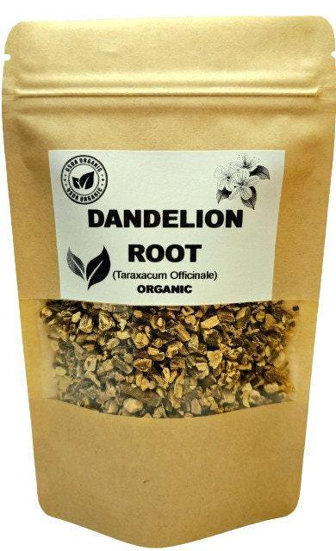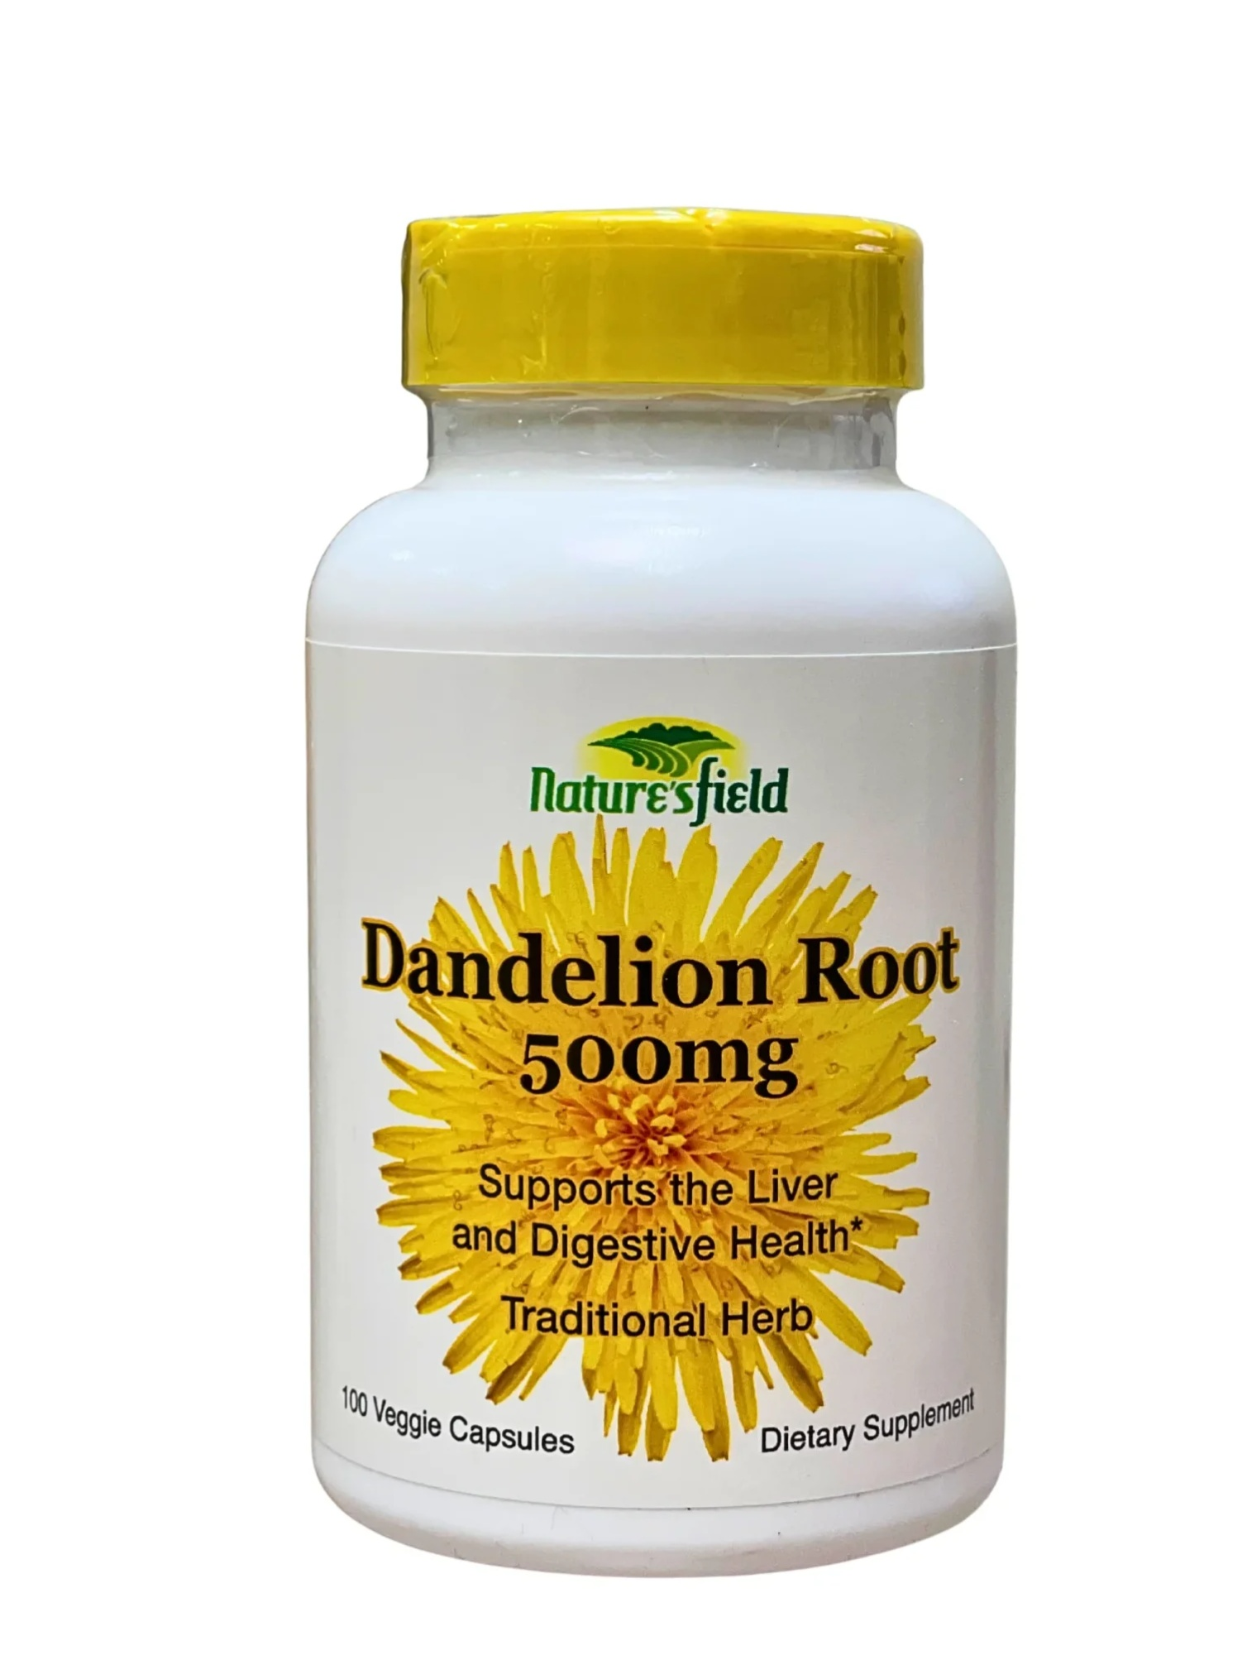

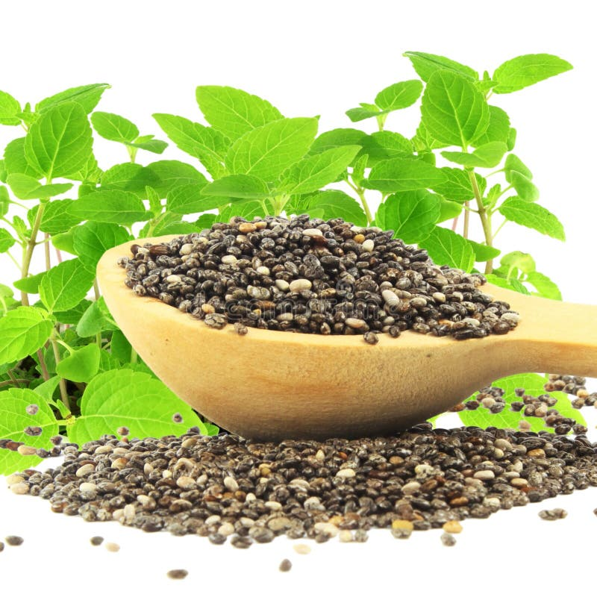CHIA SEEDS

Synonyms: Salvia hispanica seeds, chia
Biological source: Biological source of chia seeds is the edible seed obtained from the annual herbaceous plant species salvia hispanica.
Family: Lamiaceae
Geographical source: Chia seeds are native to Central America and have been cultivated in Mexico and they are grown in various countries, like Australia.
Chemical constituents:
- Omega-3 fatty acids: ALA (alpha-linolenic acid)
- Dietary fibre: High soluble and insoluble fibre content
- Proteins: Essential amino acids (lysine, leucine, isoleucine)
- Minerals: calcium, magnesium, phosphorus, potassium, iron, zinc, copper
Mechanism of action (MOA):
- High fibre content helps to promote regular bowel movements and improves digestive health.
- The soluble fiber in chia seeds absorbs water, forming a gel that helps to bulk up stool and facilitate its passage through the digestive tract.

Medicinal uses:
- Blood Sugar Control: May help stabilize blood sugar levels and improve insulin sensitivity.
- Bone Health: Rich in calcium and phosphorus, beneficial for bone density.
- Skin Health: Antioxidant and fatty acids may support skin hydration and health.

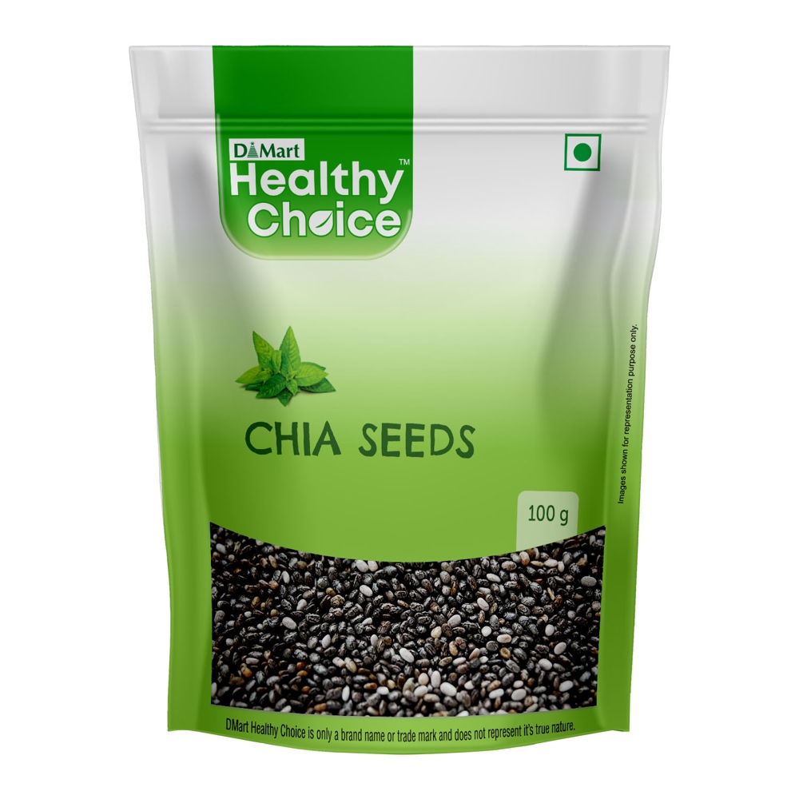Marketed product:

PSYLLIUM
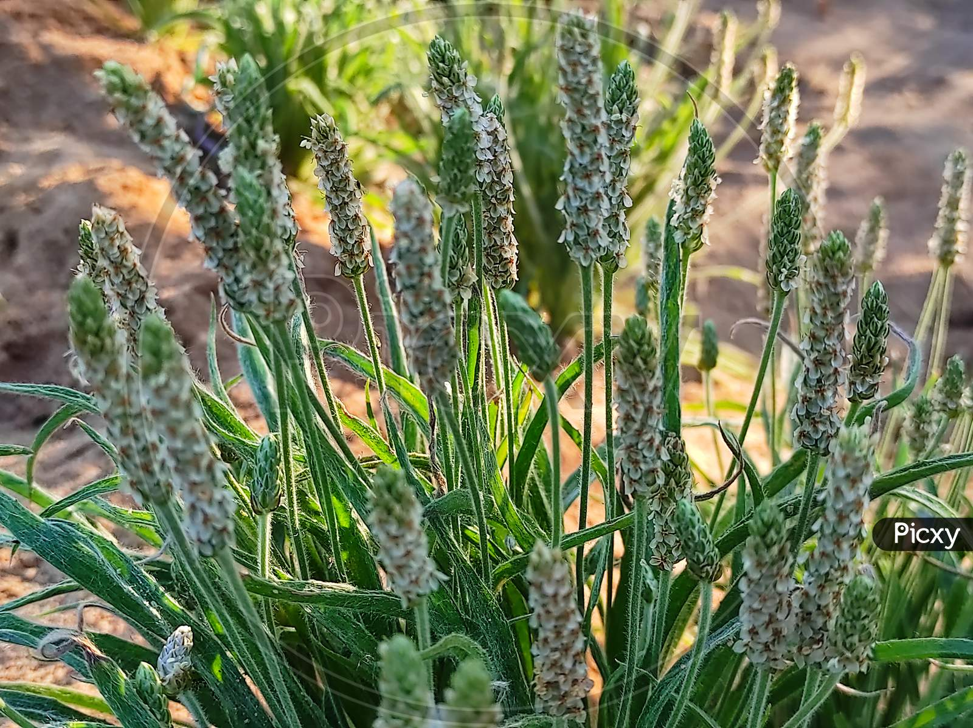
Synonym: Isphagula, Isabgol
Biological source: Psyllium is obtained from the dried, ripe seeds of several species within the plant genus plantago.
Family: Plantaginaceae
Geographical source: Psyllium is native to India, Iran and Pakistan. India is the primary global producer and exporter, accounting for approximately 80% of the worlds psyllium husk supply.
Chemical constituents:
- Dietary fibre: Soluble fiber (70-80%) and insoluble fibre
- Sugars: Arabinose, Xylose, Rhamnose and Galacturonic acid
- Proteins: Amino acids
- Glycosides: Iridoid glycosides
- Tannins: Condensed tannins
- Minerals: Calcium, magnesium, pottasium, Iron, zinc
- Other constituents: Sterols and pectins

Mechanism of action (MOA):
- Psyllium husk contains a high amount of soluble fiber that absorbs water in the gut to form a viscous gel.
- Gel formation increases stool bulk and softens it.
- Bulker stool stretches the intestinal wall, that enhance peristalsis.
- Enhanced peristalsis speeds up the movement of stool and helps to regularise bowel movement.



Medicinal uses:
- Chronic constipation: Acts as a bulk forming laxative by absorbing water and increasing stool volume.
- Irritable bowel syndrome: Improves bowel regularity and reduces constipation predominant Irritable bowel syndrome symptoms.
- Diarrhoea: Absorbs excess water in the intestine and help to normalize stool consistency.
- Inflammatory bowel conditions (mild): Soothes intestinal mucosa and improves bowel function.

Marketed product:
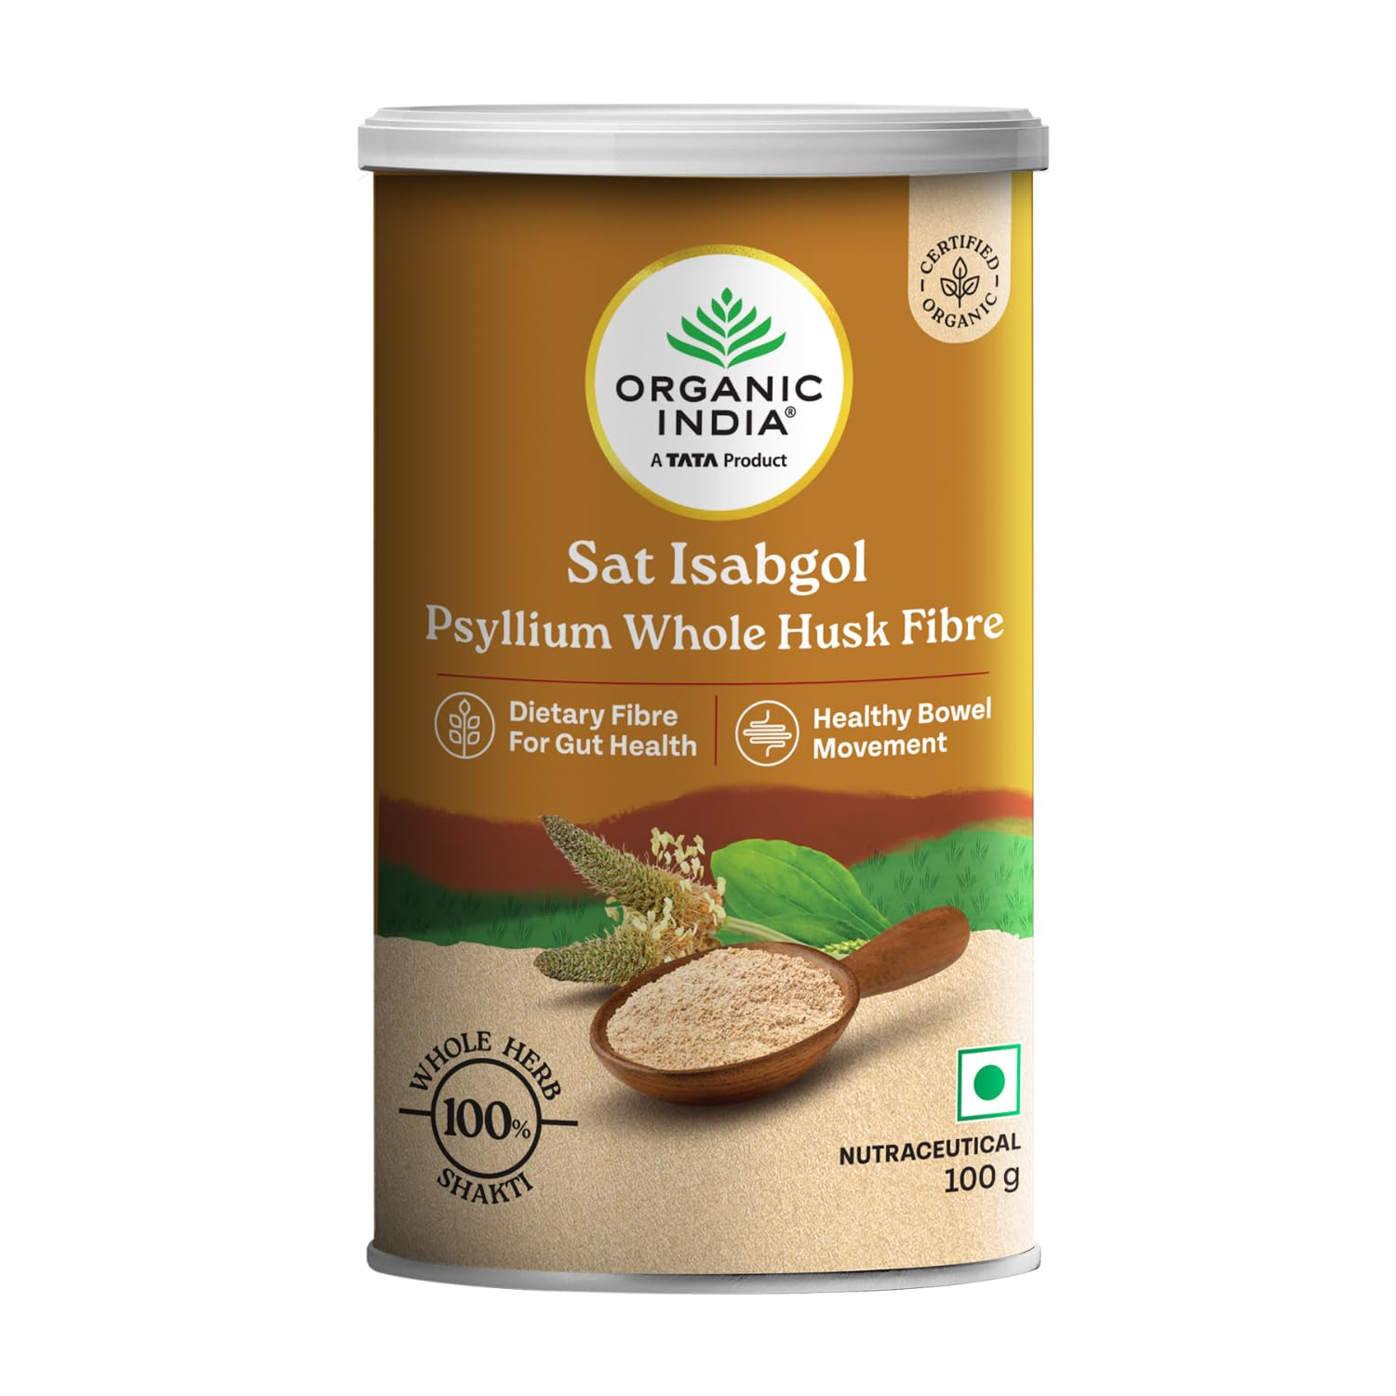
AMARANTH
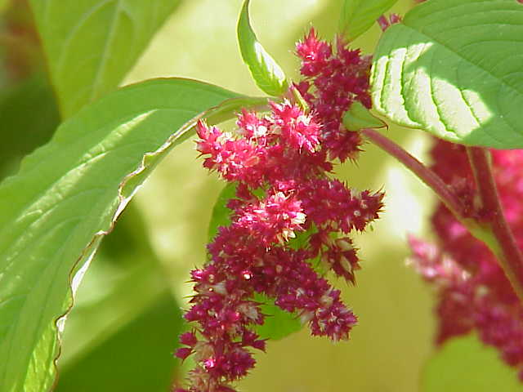
Synonym: Red amaranth, Pigweed, Tampala
Biological source: The biological source of amaranth is the plant from the genus Amaranthus.
Family: Amaranthaceae
Geographical source: It is widely cultivated in India, china, nepal, Africa and southeast Asia. Native region tropical and subtropical regions of central America and South America.
Chemical constituents:
- Carbohydrates: Starch, soluble fiber, insoluble fiber, mucilage
- Proteins: High quality proteins
- Amino acids: lysine, methionine, trytophan, leucine
- Lipids: Unsaturated fatty acids (linolenic acid, oleic acid), phospholipids
- Vitamins: Vitamin A ( beta- carotene), vitamin C, vitamin E, B- complex (B1, B2, B6 folate)
- Minerals: Calcium, magnesium, pottasium, Iron, zinc, phosphorus
- Phytochemicals: Flavonoids, phenolic acids
- Pigments: Betalains (amaranthin)
- Other constituents: Sterols, saponins (trace alkaloids)
Mechanism of action( MOA):
- Rich in fiber: Amaranth contains soluble and insoluble fiber that increases stool bulk.
- Water holding capacity: fiber absorbs water, softening stool and making them easier to pass.
- Stimulates peristalsis: Increased stool bulk stretches the intestinal wall, triggering bowel movements.
- 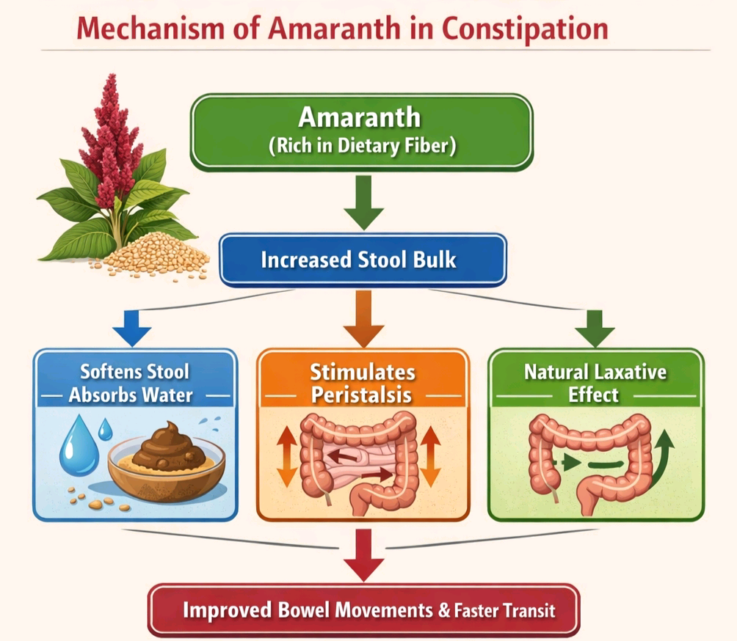Mild laxative effect: Natural mucilage and polysaccharides gently promote bowel movement and helps to reduce intestinal transit time (faster movement of fecal matter).

Medicinal uses:
- Constipation: High Dietary fiber increases stool bulk and promote bowel movement.
- Digestive disorders: Soothes the gastrointestinal tract and improves the digestion.
- Anemia: Rich in iron and folate; helps in haemoglobin formation.
- Wound healing: leaf past traditionally used for cuts, burns and skin ulcers.
- Anti diabetic: Helps to regulate blood glucose due to fiber content.

Marketed product:
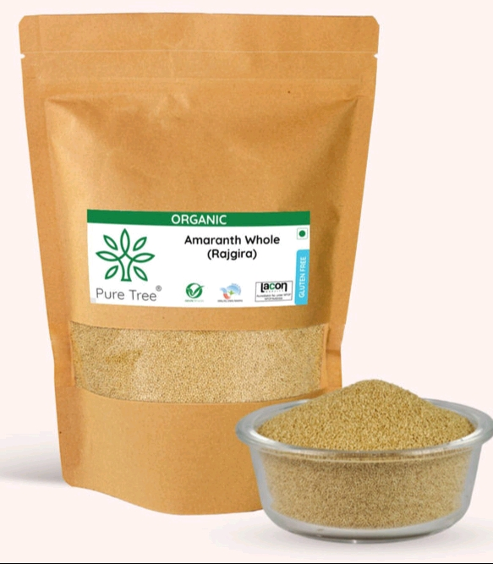

CONCLUSION:

